1. **React Router**

Step 1 : npm i react-router-dom

Step 2: react-router-dom ke import kore nite hobe, from **App.jsx**, import snippet,

import {

  Route,

  createBrowserRouter,

  createRoutesFromElements,

  RouterProvider,

} from "react-router-dom";

Step 3: After importing, implement router,

const router = createBrowserRouter(

  createRoutesFromElements(<Route index element={<h1>My App</h1>} />)

);

Step 4: Then etake const App er moddhe return korate hobe,

const App = () => {

  return <RouterProvider router={router} />;

};

From **App.jsx** full boiler plate snippet,

import React from "react";

import {

  Route,

  createBrowserRouter,

  createRoutesFromElements,

  RouterProvider,

} from "react-router-dom";

const router = createBrowserRouter(

  createRoutesFromElements(<Route index element={<h1>My App</h1>} />)

);

const App = () => {

  return <RouterProvider router={router} />;

};

export default App;

1. **React Router pages**

Suppose amader route link hobe <http://localhost:3000/about> then evabe point hobe, from App.jsx,

const router = createBrowserRouter(

  createRoutesFromElements(<Route path="/about" element={<h1>My App</h1>} />)

);

Just index page like <http://localhost:3000/> e nite hole path=”” er jaygay just index likhlei hobe, from App.jsx,

const router = createBrowserRouter(

  createRoutesFromElements(<Route index element={<h1>My App</h1>} />)

);

#importing components and adding on routes,

import HomePage from "./pages/HomePage";

const router = createBrowserRouter(

  createRoutesFromElements(<Route index element={<HomePage></HomePage>} />)

);

1. **React Outlet**

Mainly concept ta as a wrapper hishebe kaj kore, like **MainLayout.jsx** as a wrapper and tar vitorer **jsx** file child element hishebe thakbe, like components from Laravel,

Step 1: **MainLayout.jsx** naam e ekta component create kora holo

Step 2: From **App.jsx,**

const router = createBrowserRouter(

  createRoutesFromElements(

    <Route path="/" element={<MainLayout></MainLayout>}>

      <Route index element={<HomePage></HomePage>} />

    </Route>

  )

);

* MainLayout er under e baki gula wrapper

Step 3: From **MainLayout.jsx**,

* Firstly import Outlet,

import { Outlet } from "react-router-dom";

Then use it as a component, Full code snippet,

import React from "react";

import { Outlet } from "react-router-dom";

const MainLayout = () => {

  return (

    <>

      <Outlet></Outlet>

    </>

  );

};

export default MainLayout;

1. **React Outlet with components example,**

Suppose Amader main <Outlet> component er upor kono ekta component thakbe, tokhon amra evabe Components add korte parbo,

   <NavBar></NavBar>

  <Outlet></Outlet>

Full code snippet,

import React from "react";

import { Outlet } from "react-router-dom";

import NavBar from "../components/NavBar";

const MainLayout = () => {

  return (

    <>

      <NavBar></NavBar>

      <Outlet></Outlet>

    </>

  );

};

export default MainLayout;

It acts like <x-admin-master> as an example from Laravel

1. **React Router – Links**

Step 1: from jsx files, import **Link,**

import { Link } from "react-router-dom";

Step 2: Instead of anchor tags, we use links,

 <Link to="/jobs" className="text-white hover:bg-gray-900 hover:text-white rounded-md px-3 py-2">

1. **React Router – Not Found Route**

If any of the routes are not found, we can use this as a not found route,

Its from **App.jsx**,

    <Route path="*" exact={true} element={<NotFoundPage />} />

Full code snippet from App.jsx,

const router = createBrowserRouter(

  createRoutesFromElements(

    <Route path="/" element={<MainLayout></MainLayout>}>

      <Route index element={<HomePage></HomePage>} />

      <Route path="/jobs" element={<JobsPage></JobsPage>} />

      <Route path="*" exact={true} element={<NotFoundPage />} />

    </Route>

  )

);

1. **React Router redirection suggestion from Stackoverflow**

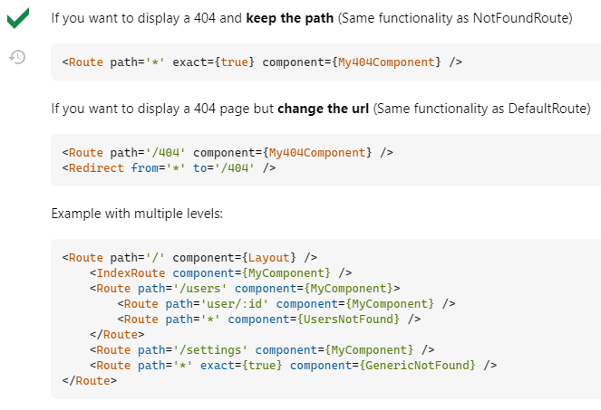

1. **for redirect o re navigate via function, use this,**

import { useNavigate } from "react-router-dom";

Then,

  const navigate = useNavigate();

using functions, kono page e redirect korar jonno function er vitor jevabe likhte hoy,

  const submitForm = (e) => {

    e.preventDefault();

    return navigate("/jobs");

  };